# 无注解配置

## 全局MP策略配置

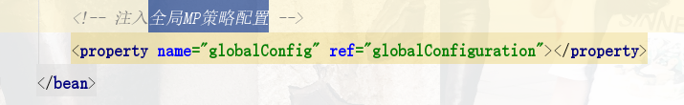

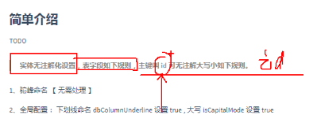

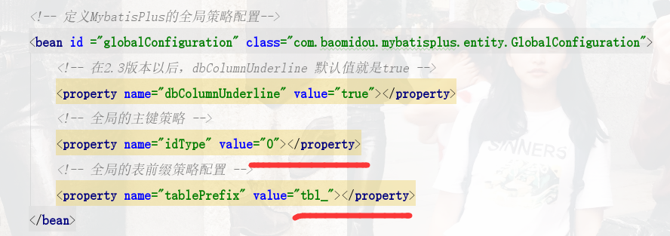

# 注解

https://mp.baomidou.com/guide/annotation.html#tablename

## [@TableName](https://github.com/baomidou/mybatis-plus/blob/3.0/mybatis-plus-annotation/src/main/java/com/baomidou/mybatisplus/annotation/TableName.java)

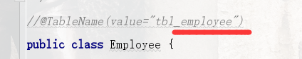

## [@TableId](https://github.com/baomidou/mybatis-plus/blob/3.0/mybatis-plus-annotation/src/main/java/com/baomidou/mybatisplus/annotation/TableId.java)

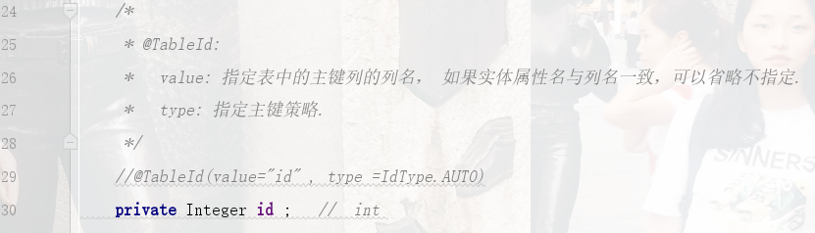

## @TableField





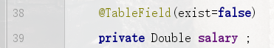

## @Version

增加version字段

ALTER TABLE tbl_employee ADD COLUMN version int(11) NULL AFTER age

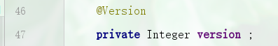

## @TableLogic

逻辑删除



## @TableField

公共字段自动填充

